**TIBCO ADB Publishing Service**

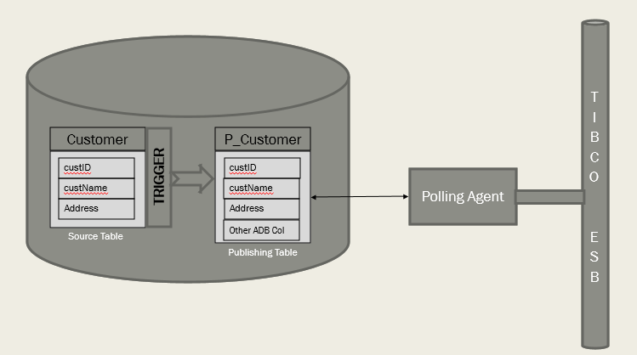

Figure 1 ADB Publishing Service

1. For every TIBCO adapter configured on a source table, TIBCO creates a table called Publishing Table (p_table).
2. TIBCO also creates a trigger on the source table, which acts as a bridge between source and p_table.
3. Whenever data is being inserted/updated/deleted from source table, it will be inserted into publishing table by means of trigger.
4. ADB has another component called polling agent (ADB agent).
5. Polling agent will be keep looking for new inserts into publishing table. (Polling interval is configurable).
6. The data published by the ADB agent will convert to ESB message (RV or EMS message) and sent to the subscriber (TIBCO BW).

**Note:**

1. The scripts of the tables and triggers which ADB agent uses will be generated during the ADB services configuring. Users can change these scripts. (Sample attached).



1. User can filter the records from publishing it to p_table when they get updated in source table
2. Status under p_table will be maintained and updated by adapter. Below are possible status values
   1. P indicates pending acknowledgement.
   2. N indicates that a new message has arrived, but has not yet been published.
   3. S indicates that one thread has got this record, and will not be taken again when polling other records.
   4. C indicates complete.
   5. F indicates failed.